**HERO WEBSITE WIREFRAMES**

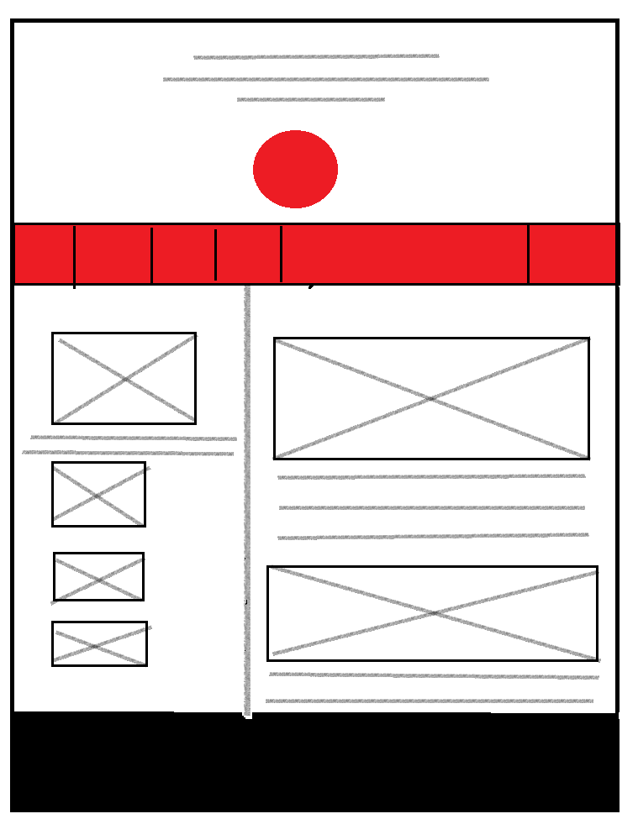

**WELCOME/HOMEPAGE**

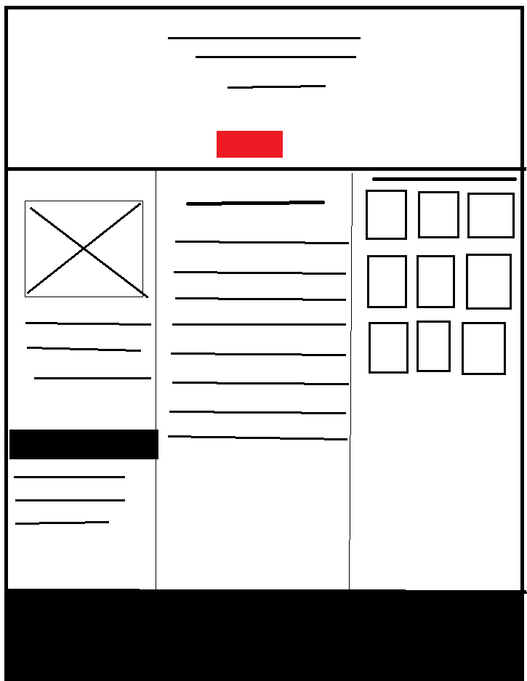

**ABOUT PAGE**



**PAGES LAYOUT**

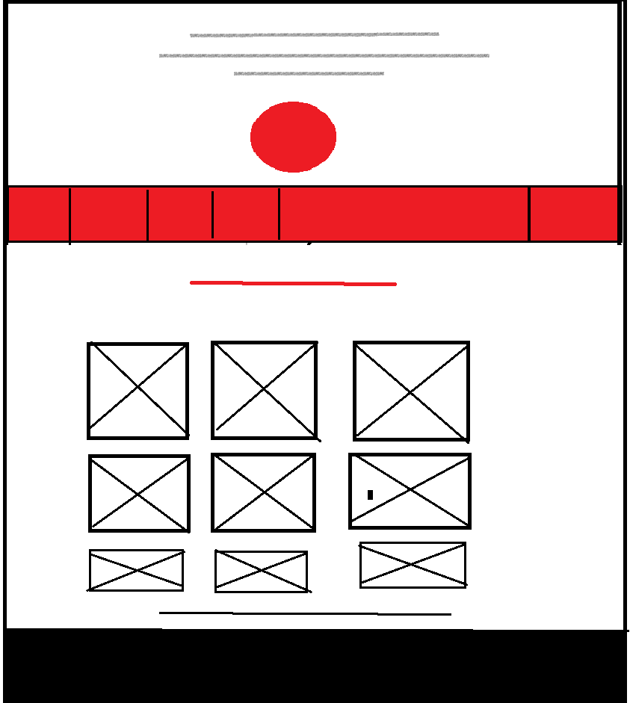

**GALLERIES PAGE**